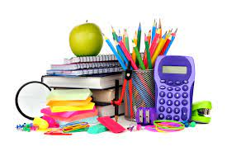

**Rutledge Middle School**

**School Supply List: 2023-2024**

**Self-Contained Class**

* 1 mesh bookbag
* A pair of headphones
* 3 highlighters
* 2 boxes of crayons
* 2 pack of pencils
* 1 pencil pouch
* 2 composition notebooks (wide-rule)
* 2 packs of dry erase markers
* 1 pack of crayola washable markers
* 2 packs of glue sticks
* 2 packs of copy paper
* 2 packs of loose leaf paper (wide-rule)
* 1 box of gallon or quart size ziplock bags
* 3 boxes of Kleenex
* 3 rolls of paper towels
* 2 containers of Clorox wipes
* 2 cans of Lysol Disinfectant spray
* 2 bottles of hand sanitizer

*CHANGES OF CLOTHES

I recommend labeling the clothes and putting them in a Ziplock bag with your child's name on it. The clothes should be weather appropriate. They will be kept at school in case your child needs them.

**A DAILY SNACK

**Additional school supplies may be requested throughout the school year**